Title: Brunstane Area Placemaking exercise
How good is your place?
The Council, Portobello Community Council and Craigmillar Community Council are holding a public event to get your views on how well your area works as a place to live.
This will be in the form of a placemaking exercise, using the Place Standard tool.
What is placemaking?
Places that work well for the community have a significant positive influence on the health and wellbeing of individuals. The opposite is also true – places that do not work well have a negative impact on health and wellbeing. The aim of placemaking is to create successful places.
We can measure the success of a place through use of a tool called the Place Standard . This consists of a series of indicators that allow the community to assess things like access to greenspace, general maintenance of an area and perception of safety. This tells us where a place is succeeding and where it can be improved.
How to get involved
This is a unique opportunity for you to get involved. This is the second time the Council has used this process. This approach was also used in a well attend series of events in Queensferry:
http://planningedinburgh.com/2015/07/24/queensferry-placemaking-exercise/
http://planningedinburgh.com/2015/12/21/making-use-of-the-place-standard-in-queensferry/
We’d like as many of the community as possible to get involve to help make the process work.
People will be put into groups and a facilitator will ask you and other people in your group a series of questions. As a group you will have to agree on an answer to the question. There will be someone taking a note of what people are discussing. At the end of the questions a compass diagram will be drawn to show the output of the answers (like the one below).

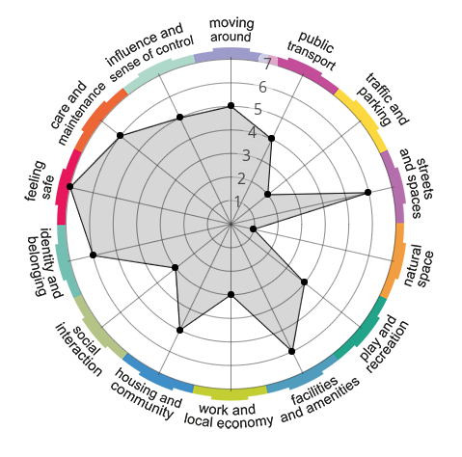
Example of Place Standard Compas

When?
- Saturday 19 March (Edinburgh College) between 10pm and 1pm
- Tuesday 22 March (Edinburgh College) between 5pm and 8pm

What next?
The outputs from these discussions will help the Council, the community and developers to better understand the needs of the community in light of future development.
The outcomes will be shared with the developers of the new housing sites identified in Second Proposed Local Development Plan so they can shape their proposals to take account of the strengths and weaknesses identified by the community.
For more information, contact:
Elizabeth McCarroll (Elizabeth. McCarroll@edinburgh.gov.uk) or Chloe Porter(chloe.porter@edinburgh.gov.uk)

